**1. (True/False) When learning decision trees, smaller depth USUALLY translates to lower training error.**

True

**False**

**2. (True/False) If no two data points have the same input values, we can always learn a decision tree that achieves 0 training error.**

True

**False**

**True**

False

**3. (True/False) If decision tree T1 has lower training error than decision tree T2, then T1 will always have better test error than T2.**

True

**False**

**4. Which of the following is true for decision trees?**

Model complexity increases with size of the data.

**Model complexity increases with depth.**

None of the above

**5. Pruning and early stopping in decision trees is used to**

**combat overfitting**

improve training error

None of the above

**6. Which of the following is NOT an early stopping method?**

Stop when the tree hits a certain depth

Stop when node has too few data points (minimum node “size”)

**Stop when every possible split results in the same amount of error reduction**

Stop when best split results in too small of an error reduction

**7. Consider decision tree T1 learned with minimum node size parameter = 1000. Now consider decision tree T2 trained on the same dataset and parameters, except that the minimum node size parameter is now 100. Which of the following is always true?**

**The depth of T2 >= the depth of T1**

**The number of nodes in T2 >= the number of nodes in T1**

The test error of T2 <= the test error of T1

**The training error of T2 <= the training error of T1**

**8. Questions 8 to 11 refer to the following common scenario:**

**Imagine we are training a decision tree, and we are at a node. Each data point is (x1, x2, y), where x1,x2 are features, and y is the label. The data at this node is:**

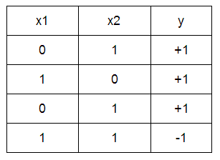

**What is the classification error at this node (assuming a majority class classifier)?**

0.25

**9. Refer to the scenario presented in Question 8.**

**If we split on x1, what is the classification error?**

0.25

**10. Refer to the scenario presented in Question 8.**

**If we split on x2, what is the classification error?**

0.25

**11. Refer to the scenario presented in Question 8.**

**If our parameter for minimum gain in error reduction is 0.1, do we split or stop early?**

Split

**Stop early**